**A MAGAZINE ARTICLE**

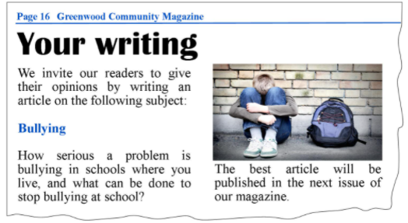

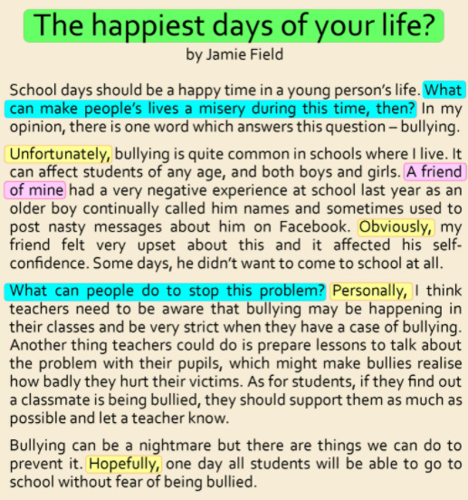

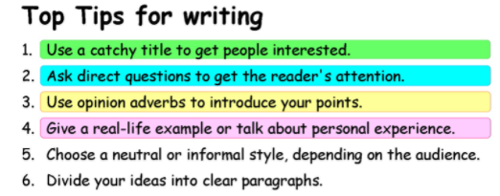

Match the words with the definitions.

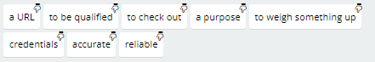

-to look at and evaluate

-correct and without mistakes

-an aim of doing or creating something

-the experience and achievements that a person has for a particular job

-to have the necessary skills, knowledge or experience to do a particular job

-trusted to do what is expected

-the technical name for a website's address. It stands for 'Uniform Resource Locator'

-to think carefully about different viewpoints before you make a decision

**An ARTICLE**

Váš školní časopis vyhlásil pro své čtenáře soutěž, ve které je vyzývá, aby napsali článek na téma

**“Den strávený v přírodě”.** Rozhodl/a jste se soutěže zúčastnit.

Napište **o dni stráveném v přírodě článek** v rozsahu **120-150 slov**, ve kterém:

* **uvedete, kdy, kde a s kým** jste tento den strávil/a;
* **popíšete** místo, **kde** jste tento den strávil/a;
* **budete vypravovat o tom, co** jste v přírodě tento den zažil/a;
* **napíšete, jak** jste se tento den cítil/a a **proč**.

**A Day in Nature with Friends**

What a day. I will probably never forget the fun I had with my friends in the Sedmihorky Camp last summer holidays.

The camp is located in Český Ráj, it is something like a national park with truly amazing natural monuments called “rock towns“ – huge rocks with little canyons and many footpaths. The rocks kind of resemble buildings in a town.

That day we decided to sleep outdoor in one of the many caves in the Hrubá Skála Rock Town. We found a suitable place, made a fireplace and played the guitar, sang songs, drank beer etc. In the end one of my friends burnt the guitar, just like the rock stars do. It may look weird but that was one of the funniest moments in my life.

The nature, the setting, my friends, the fun – all of that made me feel so

**CHECKING OUT WEBSITES**

